Check the following database:

DEPARTMENTS:

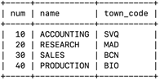

EMPLOYEES:

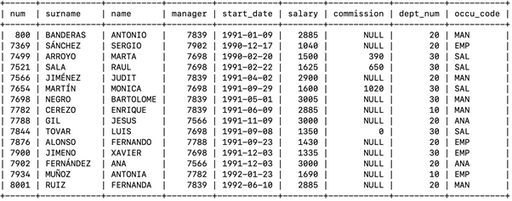

OCCUPATIONS:

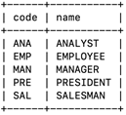

TOWNS:

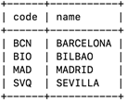

Do the following queries with that database:

1. Display the number of employees in each department. Use GROUP BY to group by department.

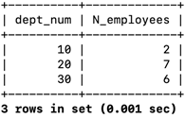

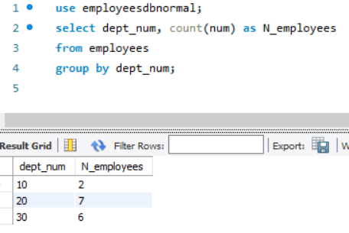

2. For each occupations obtain the average of salary.

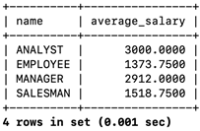

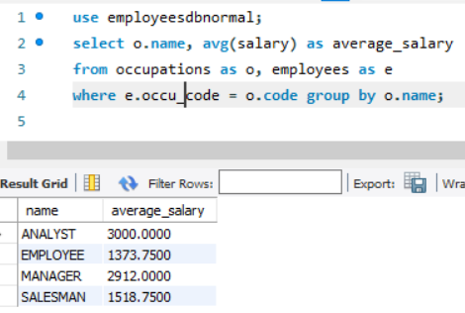

3. Display the departments with more than 5 employees. Use GROUP BY to group by department and HAVING to establish the condition on the groups.

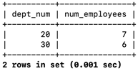

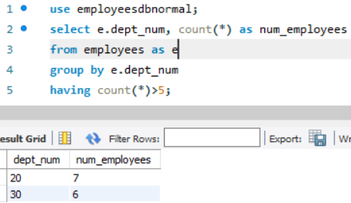

4. Find the average wages (=”media de los salarios”) of each department (use the function avg and GROUP BY).

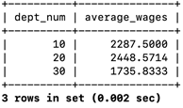

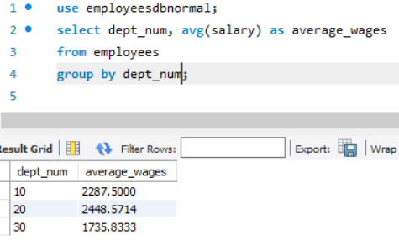

5. Display the surname of the salesmen of the 'SALES' department.

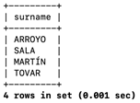

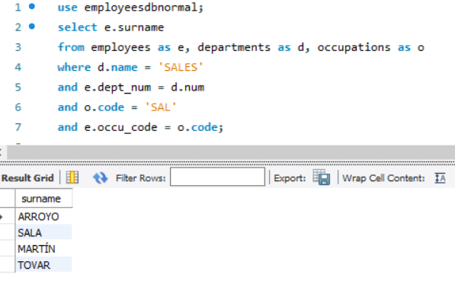

6. Display the sum of salariesof the 'SALES' department.

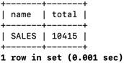

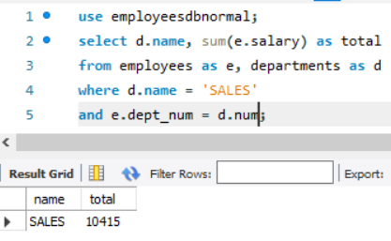

7. Display the count of employees with occupation “EMPLOYEE” in every department (show the name of the department).

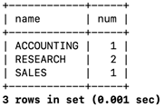

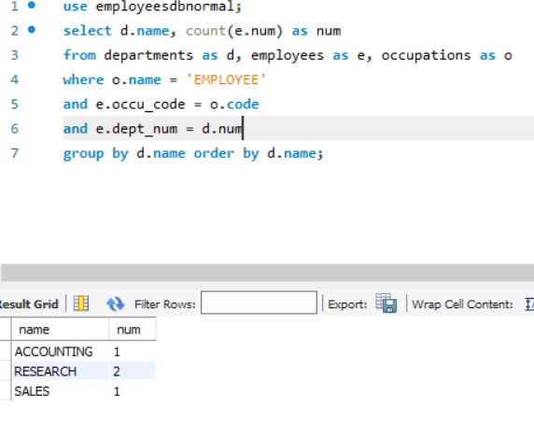

8. Show the number of different occupations in each department.

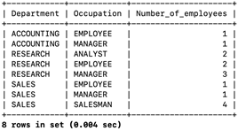

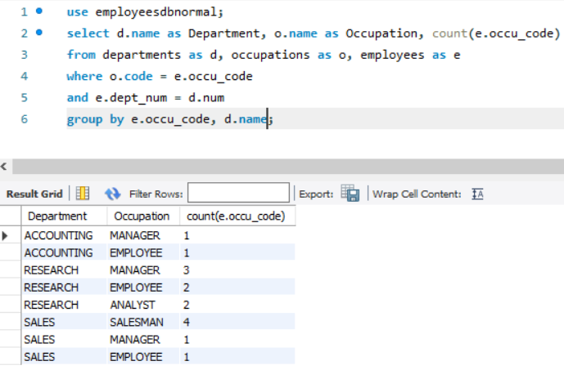

9. Show departments that have more than two people working in the same occupation.

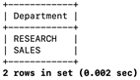

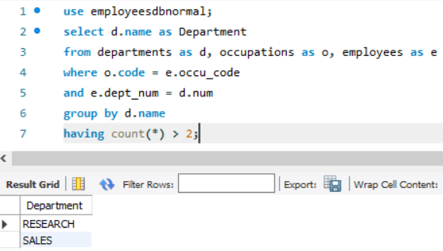

10. Displays a query that is the union between the table OCCUPATIONS and TOWNS.

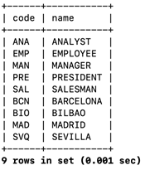

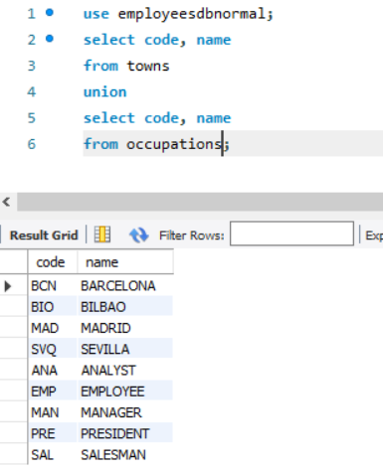

11. Do the same query than in exercise 10 but order the results by name.

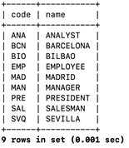

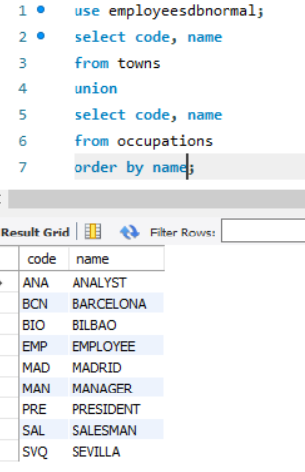

12. Select the occupation names of all the employees of the department with name ‘RESEARCH’ and do the union of this query with the selection of the occupation names of the employees of the department with name ‘SALES’. Use union operator.

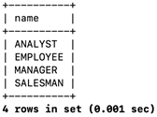

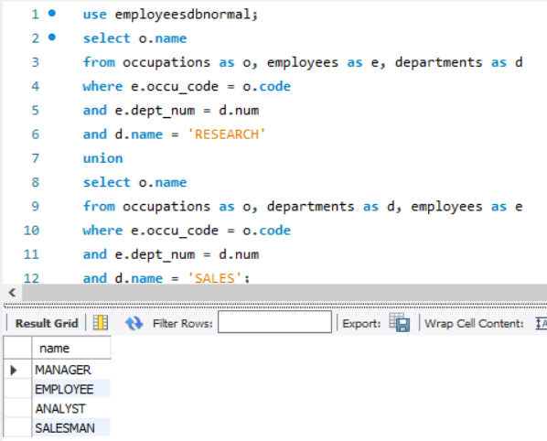

13. Repeat the last query showing the repeated results (union all).

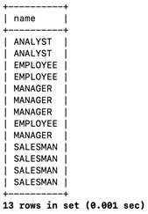

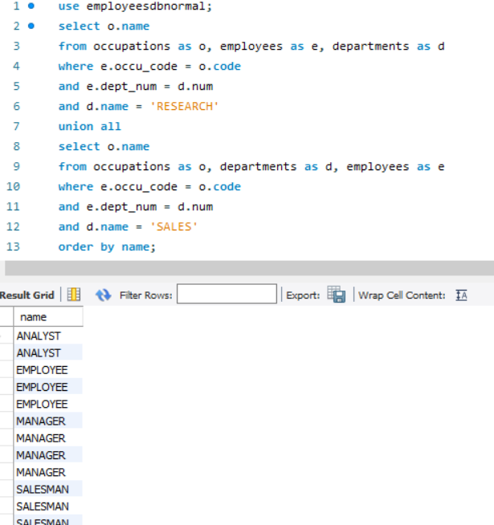

14. Display the number of sellers in the 'SALES' department.

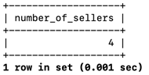

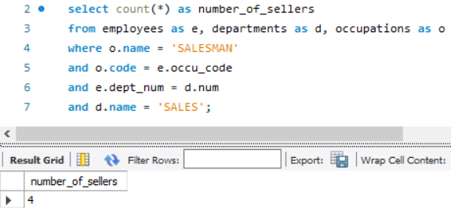

15. Display the surnames and occupations of the employees of the 'SALES' department.

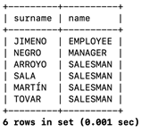

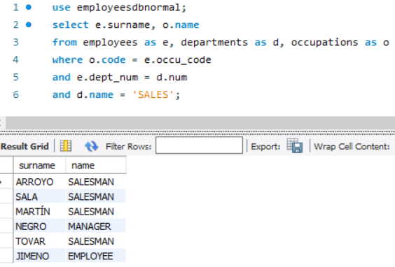

16. Display the number of employees and occupations of the employees of the 'SALES' department.

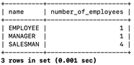

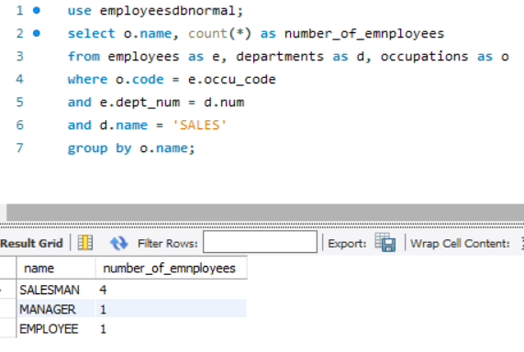

17. Display the number of employees of each department whose profession is "EMPLOYEE".

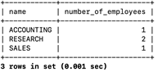

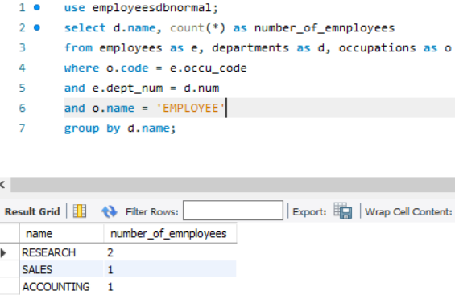

18. Display de department names and the count of employees working into them.

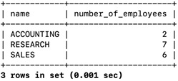

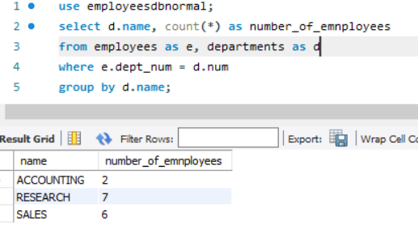

19. Display the maximum number of employees of all the departments (clue: you need exercise 18 as a subquery and you should use MAX function).

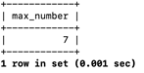

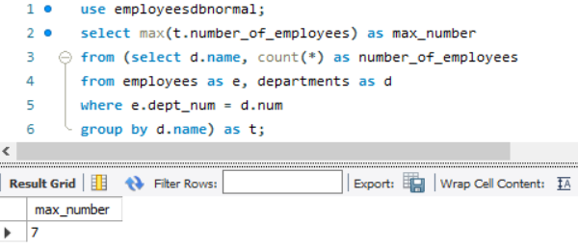

20. Show the departments whose average salary is greater than the average of salaries of all employees.

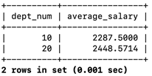

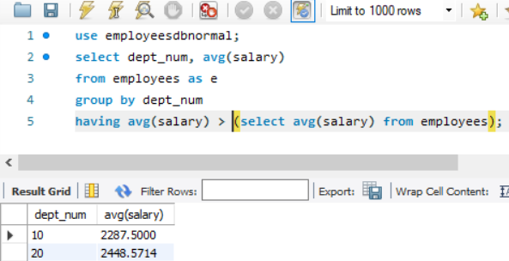

21. DANGER, this is for PROS: Display the name of the department with more employees and its number of e

mployees (clue you must use HAVING with a subselect inside).

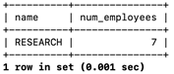

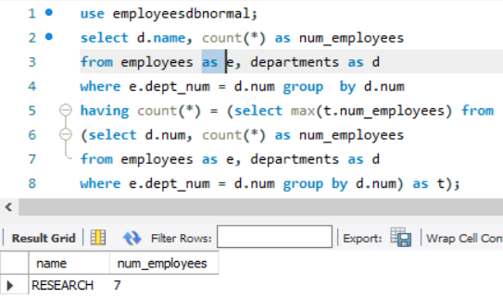

22. Repeat 12 changing “union” for “intersect”.

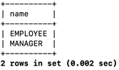

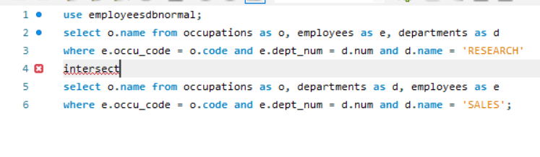**He buscado la sintaxis en 3 páginas (100% fiables como Microsoft o AWS amazon) y en tema de sintaxis está correctamente, he probado paréntesis, comas, comillas, de todo y no funciona me lo coge como error al igual que EXCEPT. Y en** [**https://www.w3schools.com/sql/sql_union.asp**](https://www.w3schools.com/sql/sql_union.asp) **esta página que he encontrado la descripción de todos los comandos que tiene sql, no aparecen estos dos.**

23. Repeat 22 but do not use intersect operator to query the same data (clue: IN operator).



